**/Supplementary materials**

**Analytically quantifying and locating maximum width of contaminant plumes, and estimating plume area**

P. K. Yadava,*, S. I. Ibrahima,c, R. Liedla, T. Grischekd, B. R. Chaharb

*aTechnische Universität Dresden (TUD), Germany*

*bIndian Institute of Technology Delhi (IITD), India*

*cHelmholtz-Zentrum für Umweltforschung (UFZ), Germany*

*dHochschule für Technik und Wirtschaft Dresden (HTWD), Germany*

**\*Corresponding Author:** Prabhas K Yadava: [**prabhas.yadav@tu-dresden.de**](mailto:prabhas.yadav@tu-dresden.de)

1. **Additional description of non-linear system solvers**

*Wmax* and *Xwmax*, as can be seen in eq. (10), are dependent on several factors, and therefore the challenge is to find a solver that more generally converge to a solution. Standard textbooks on system solvers e.g., Kelley (2003) list and describe several methods available for solving non-linear systems. The nonlinear system solvers differ mostly in the approximation of the Jacobian, the matrix of differentials, which is used in the iteration process. The most common method, the extension of the Newton-Raphson method for a single non-linear equation, may not be suitable as obtaining expressions of Jacobian directly from eqs. (10) and (11) and their subsequent use in the iteration is not readily possible. In such case, methods such as Broyden1 and Broyden2 (Broyden, 1965; Kelley, 2003) that numerically approximates Jacobian can be among the preferred methods. Both Broyden methods uses the finite difference approach for approximating the Jacobian. Broyden1 approximates the true Jacobian, whereas the Broyden2 approximates the inverse of the Jacobian (Kelley, 2003). More newer methods such as Newton–Krylov (called NK hereafter) employs Jacobian free iterations using Krylov subspace (Kelley, 2003; Knoll & Keyes, 2004). The NK method first employs the inner iteration, a linear iterator, also called Krylov linear solvers, determining the direction of the solution. The outer iteration, a nonlinear iteration step is then used for finding the solution. Different variants of NK solvers can be found in the literature. These variants are based on the Krylov solver types. Particularly suitable Krylov solver for this work, being a (small) system of only two equations, is the faster variant of the Generalized Minimal RESidual (GMRES) method called Loose GMRES (or LGMRES, see Baker et al., 2005). As information on the suitability of solver is not known, three different solvers- Broyden1, Broyden2 and NK-LGMRES are considered in this work.

Iterating solvers in general have a very high dependency on the initial guess of the solution. This is more critical for nonlinear system solvers, as guesses for more than one unknown (e.g., *Wmax* and *Xwmax* ) have to be made. The level of non-linearity in eqs. (10) and (11) makes finding these guesses a challenge. *Xwmax* lie between the source (*x* = 0) and *Lmax*, which can be computed using eq. (5). For the plume shape similar to the one shown in Fig. 2, *Lmax*/2 can be a good guess of *Xwmax*. However, the mid-point along the *x*−axis may not be a good choice when *Wmax* is located very close to the source or in the vicinity of *Lmax*. Factors such as source geometry and dispersivity also have to be considered for selecting these guesses. Obtaining an initial guess of *Wmax* is more complicated as only *Sw* and *αTh* act along the *xy*− plane. Literature scarcely provide information on *Sw* and *Wmax* including relating them. Furthermore, the impact of *αTh* and *Sw* on *Wmax* have not been explored. Consequently, the numerical iterator that is more flexible with the choice of initial guess is required. NK-LGMRES solver, compared to Broyden1, Broyden2, is considered more flexible with the choice of initial guesses (see Kelley, 2003). However, this is not known for the system that is defined in this work.

### **Additional description on Method for quantifying Wmax and Xwmax**

Heuristic approach has to be employed as only very limited information on the most suitable solver and approach to make initial guesses of the solution are available. Therefore, over 1000 problem cases comprising different combinations of model parameters (see Table 1 in the MS) are first developed. The solution for *Wmax* and *Xwmax* of each problem cases are then attempted using the above-mentioned three solvers. Parameter sensitivities suggested in Liedl et al. (2011) are considered in developing the problem cases. Accordingly, source geometry and dispersivities are emphasized compared to reaction parameters. The solution procedure is as follows:

1. *Lmax* using eq. (5) is first obtained.
2. The initial guess for *Xwmax* is then based on the obtained *Lmax*.
3. The initial guess of *Wmax* is made based on the source width (*Sw*).
4. The guesses are adjusted until the solver converges to a solution.

An interactive simulation code (a web-browser based: <https://github.com/prabhasyadav/Wmax> provides complete details of the methods used in this work. The solver codes used in this work were obtained from the open-source Python programming library SciPy

(https:// docs.scipy.org/doc/scipy/reference/optimize.html#multidimensional).

1. **Tabulation of initial guesses for solving *Wmax* and *Xwmax***

**Table 1**: Initial guesses for different model parameter combinations that led to a solution using NK solvers (from Sapkota, 2020)

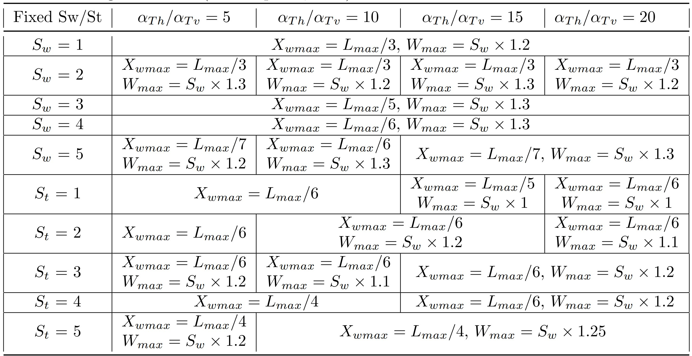

The online link: <https://github.com/prabhasyadav/Wmax> provides interactive codes, which can be simulated in any web-browser, that was used to obtain all the results in the paper. Additionally, the link also provides complete set of results dataset (csv format), and fit analysis codes and results used in developing Fig. 3 of the paper.

**Reference:**

1. Baker, A. H., E. R. Jessup, and T. Manteuffel. 2005. A Technique for Accelerating the Convergence of Restarted GMRES. *SIAM Journal on Matrix Analysis and Applications* 26, no. 4: 962–84, <https://doi.org/10.1137/S0895479803422014>.
2. Broyden, C. G. 1965. A class of methods for solving nonlinear simultaneous equations. *Mathematics of Computation* 19, no. 92: 577–577, <https://doi.org/10.1090/S0025-5718-1965-0198670-6>.
3. Kelley, C. T. 2003. *Solving Nonlinear Equations with Newton’s Method*. Society for Industrial and Applied Mathematics, <https://doi.org/10.1137/1.9780898718898>.
4. Sapkota, P. (2020). The Role of Contaminant Source Geometries on the Transverse Extension of Plumes. M.Sc. Thesis, Hochschule für Technik und Wirtschaft Dresden/ Technische Universität Dresden, Dresden, Germany. Supervisors: P. K. Yadav, R. Liedl and T. Grischek